CSA1717-ARTIFICIAL INTELLIGENCE
PRACTICAL LAB EXPERIMENTS
RAGAVI S – (192565027)

EXPERIMENT 4: VACUUM – CLEANER PROBLEM
Aim
The aim of this experiment is to implement a reflex-based Vacuum Cleaner agent that senses its environment and cleans a two-room grid space (Room A and Room B) by removing dirt.
Objective
To implement a simple reflex agent that perceives its current location and status to make immediate, rule-based cleaning and movement decisions without requiring long-term memory.
Algorithm
Step 1: Define the initial state of the environment, including the starting location of the vacuum cleaner (Room A or Room B) and the status of both rooms (Clean or Dirty).
Step 2: Read the current sensor input of the vacuum cleaner to determine its location and whether the current room is Clean or Dirty.
Step 3: If the status of the current room is Dirty, perform the Suck action to clean the room, and update its status to Clean.
Step 4: If the current room is already Clean, check the agent's location to decide the next move:
- If the agent is in Room A, execute the Move Right action to switch to Room B.
- If the agent is in Room B, execute the Move Left action to switch to Room A.
Step 5: Move to the adjacent room and repeat the sensor check to evaluate its cleanliness.
Step 6: If the room is Dirty, clean it using the Suck action.
Step 7: Once both rooms are confirmed to be Clean, stop the program and display the total performance score or step count.
Source Code
def reflex_vacuum_agent(location, status_a, status_b):
state = {'A': status_a, 'B': status_b}
current_loc = location
path = []

print(f"Initial State -> Location: {current_loc}, Room A: {'Dirty' if status_a else 'Clean'}, Room B: {'Dirty' if status_b else 'Clean'}\n")

# Run loop until both rooms are clean
while state['A'] == 1 or state['B'] == 1:
path.append(f"({current_loc}, {'Dirty' if state[current_loc] else 'Clean'})")

if state[current_loc] == 1:
print(f"Location {current_loc} is Dirty. Action: SUCK")
state[current_loc] = 0 # Clean the room
else:
if current_loc == 'A':
print("Location A is Clean. Action: MOVE RIGHT")
current_loc = 'B'
else:
print("Location B is Clean. Action: MOVE LEFT")
current_loc = 'A'

# Append final clean state
path.append(f"({current_loc}, Clean)")
print(f"\nBoth rooms are clean! Final state path:")
print(" -> ".join(path))

# --- Run the Simulation ---
# Parameters: (Initial Location, Status A, Status B) | 1 = Dirty, 0 = Clean
reflex_vacuum_agent(location='A', status_a=1, status_b=1)

Flowchart
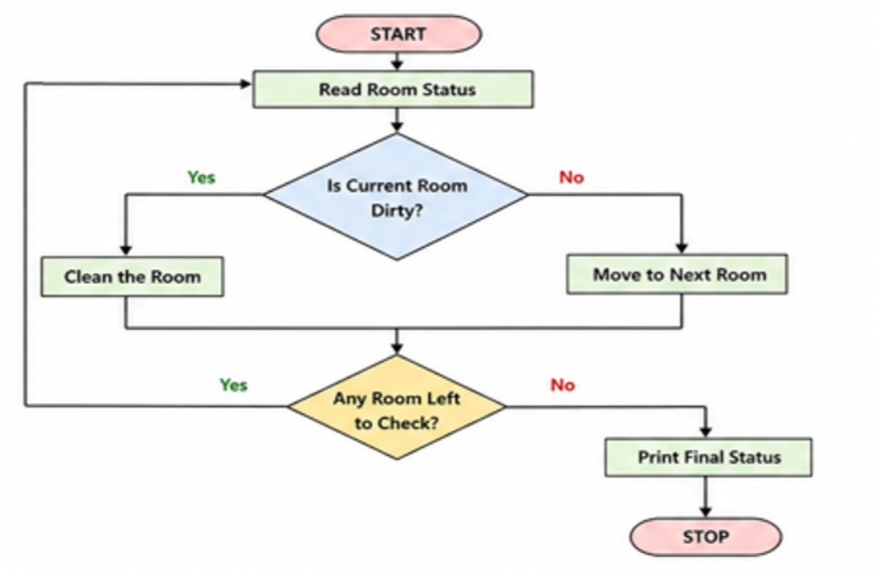
Output
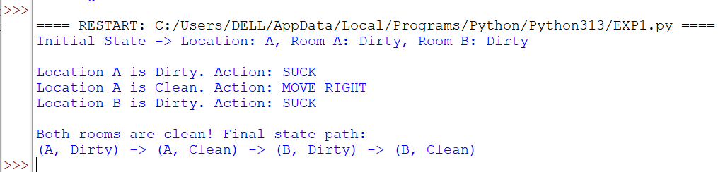
Result
The Vacuum Cleaner World environment was successfully simulated, and the reflex agent efficiently cleaned all dirty rooms using optimal movement patterns.

